

**Course name:** INTRODUCTION TO DATABASE

**Course Teacher:** JUENA AHMED NOSHIN

**Section:** F

**Project name:** TEACHER MONITORING MANAGEMENT SYSTEM

**Group members:**

|  |  |
| --- | --- |
| Name | Id |
| ABDULLAH FAISAL | 17-33471-1 |
| ABEDIN KAZI FAKHRUL | 17-33594-1 |
| BHUIYAN FOKRUL ISLAM | 17-33535-1 |
| ISLAM HEDAETUL | 17-33554-1 |

**Content List:**

|  |  |
| --- | --- |
| No.1 | Introduction |
| No.2 | Scenario |
| No.3 | ER Diagram |
| No.4 | Normalization |
| No.5 | Table Create |
| No.6 | Data Insertion |
| No.7 | Query Writing |
| No.8 | Conclusion |

**INTRODUCTION:** A database management system (DBMS) is a computer software application that interacts with ends-user, other application and the database itself to capture an analyze data. A general –purpose DBMS allows the definition, creation, querying, update and administration of database.

In our project (Teacher monitoring management system) was created by the concept of DBMS. So the main purpose of our project is to know about the basic concept of database management system.

**SCENARIO:** In a teacher monitoring management system a university contains an administration where university has code number, location and name. Administration has an id, name, phone (multivalued), email and designation (multivalued). Administration control departments where the department has id, name, and sector (multivalued). The department appoint teacher where a teacher can be also the head of the department. The teacher has different id, email, address, name, phone (multivalued) and join date. The department also monitor the teacher and distribute courses. Here is also a chance of faculty exchange which is done by the department where faculty can be change home or abroad university and this exchange has an exchange id. The courses have different code, credit and name. University gives salary which was taken by the teacher where the salary has salary no, amount and policy. The teachers judged by TPE. TPE has TPE no, TPE performance, TPE comment option. TPE also offer promotion which has a number and designation. Teachers give attendance which is observe by the registrar and the attendance has a date, on time and off time. Register has different id, name, phone, email. It was also noticed that teacher can spent vacation which is daily, semester wise which has also a date, application and this is also monitor by the registrar. A teacher can communicate with the foreign faculty. The foreign faculty has name, country, designation, social account, id and institute. Any teacher can research, also the research has research field, id and name. In exam result teacher can deliver grade with a grade system and number. The grade system gives two way one is average and one is break down. During leisure time a teacher present consulting hour which has fixed hour and room number.

**Normalization**

**UNIVERSITY ---1---CONTAINS ---1---ADMINISTRATION**

UNF:

contain (u_code, u_name, u_location, a_id, a_name, a_phone, a_email, a_dessignation)

1NF:

a_phone, a_designation is multivalued attribute

contain (u_code, u_name, u_location, a_id, a_name, a_phone, a_email, a_dessignation)

2NF:

(u_code, u_name, u_location)

(a_id, a_name, a_email, a_dessignation)

3NF:

(u_location)

(u_code, u_name)

(a_id, a_name, a_phone, a_email, a_dessignation)

BCNF: already in BCNF

(u_location)

(u_code, u_name)

(a_id, a_name, a_phone, a_email, a_dessignation)

4NF: already in 4NF

(u_location)

(u_code, u_name)

(a_id, a_name, a_phone, a_email, a_dessignation)

Table:

|  |
| --- |
| l_id, u_location, **u_code** |
| u_code, u_name, **a_id** |
| a_id, a_name, a_phone, a_email, a_dessignation |

**ADMINISTRATION---1---CONTROL---1---DEPARTMENT**

UNF:

control (a_id, a-name, a_phone, a_email, a_dessignation, d_id, d_name, d_sector)

1NF:

a_phone, a_dessignation are multivalued attribute.

control (a_id, a-name, a_phone, a_email, a_dessignation, d_id, d_name, d_sector)

2NF:

(d_id, d_name, d_sector)

(a_id, a-name, a_phone, a_email, a_dessignation)

3NF:

(d_id, d_name, d_sector)

(a_id, a-name, a_phone, a_email, a_dessignation)

BCNF:

already in BCNF

(d_id, d_name, d_sector)

(a_id, a-name, a_phone, a_email, a_dessignation)

4NF:

already in 4NF

(d_id, d_name, d_sector)

(a_id, a-name, a_phone, a_email, a_dessignation)

Table:

|  |
| --- |
| d_id, d_name, d_sector, **a_id** |
| a_id, a-name, a_phone, a_email, a_dessignation |

**DEPARTMENT---1---MONITOR---*---TEACHER**

UNF:

monitor (d_id, d_name, d_sector, t_id, t_name, t_phone, t_email, t-address, join_date)

1NF:

t_phone is a multivalued attribute

monitor (d_id, d_name, d_sector, t_id, t_name, t_phone, t_email, t-address, join_date)

2NF:

(d_id, d_name, d_sector)

(t_id, t_name, t_phone, t_email, t-address, join_date)

3NF:

(d_id, d_name, d_sector)

(t_id, t_name, t_phone, t_email, t-address, join_date)

BCNF:

already is BCNF

(d_id, d_name, d_sector)

(t_id, t_name, t_phone, t_email, t-address, join_date)

4NF:

already is 4NF

(d_id, d_name, d_sector)

(t_id, t_name, t_phone, t_email, t-address, join_date)

Table:

|  |
| --- |
| d_id, d_name, d_sector |
| t_id, t_name, t_phone, t_email, t-address, join_date, **d_id** |

**DEPARTMENT---1---HEAD---*---TEACHER**

UNF:

head (d_id, d_name, d_sector, t_id, t_name, t_phone, t_email, t-address, join_date)

1NF:

t_phone is a multivalued attribute

head (d_id, d_name, d_sector, t_id, t_name, t_phone, t_email, t-address, join_date)

2NF:

(d_id, d_name, d_sector)

(t_id, t_name, t_phone, t_email, t-address, join_date)

3NF:

(d_id, d_name, d_sector)

(t_id, t_name, t_phone, t_email, t-address, join_date)

BCNF:

already is BCNF

(d_id, d_name, d_sector)

(t_id, t_name, t_phone, t_email, t-address, join_date)

4NF:

already is 4NF

(d_id, d_name, d_sector)

(t_id, t_name, t_phone, t_email, t-address, join_date)

Table:

|  |
| --- |
| d_id, d_name, d_sector |
| t_id, t_name, t_phone, t_email, t-address, join_date, **d_id** |

**DEPARTMENT---1---APPOINT---*---TEACHER**

UNF:

appoint (d_id, d_name, d_sector, t_id, t_name, t_phone, t_email, t-address, join_date)

1NF:

t_phone is a multivalued attribute

appoint (d_id, d_name, d_sector, t_id, t_name, t_phone, t_email, t-address, join_date)

2NF:

(d_id, d_name, d_sector)

(t_id, t_name, t_phone, t_email, t-address, join_date)

3NF:

(d_id, d_name, d_sector)

(t_id, t_name, t_phone, t_email, t-address, join_date)

BCNF:

already is BCNF

(d_id, d_name, d_sector)

(t_id, t_name, t_phone, t_email, t-address, join_date)

4NF:

already is 4NF

(d_id, d_name, d_sector)

(t_id, t_name, t_phone, t_email, t-address, join_date)

Table:

|  |
| --- |
| d_id, d_name, d_sector |
| t_id, t_name, t_phone, t_email, t-address, join_date, **d_id** |

**DEPARTMENT---1---DO---1---TEACHER_EXCHANGE**

UNF:

do (d_id, d_name, d_sector, t_exc_id, t_exc_home, t_exc_abroad)

1NF:

do (d_id, d_name, d_sector, t_exc_id, t_exc_home, t_exc_abroad)

2NF:

(d_id, d_name, d_sector)

(t_exc_id, t_exc_home, t_exc_abroad)

3NF:

(d_id, d_name, d_sector)

(t_exc_id, t_exc_home, t_exc_abroad)

BCNF:

already in BCNF

(d_id, d_name, d_sector)

(t_exc_id, t_exc_home, t_exc_abroad)

4NF:

already in 4NF

(d_id, d_name, d_sector)

(t_exc_id, t_exc_home, t_exc_abroad)

Table:

|  |
| --- |
| d_id, d_name, d_sector |
| t_exc_id, t_exc_home, t_exc_abroad, **t_id, d_id** |

**DEPARTMENT---1---DISTRIBUTE---1---COURSE**

UNF:

distribute (c_credit, c_code, c_name, d_id, d_name, d_sector)

1NF:

distribute (c_credit, c_code, c_name, d_id, d_name, d_sector)

2NF:

(c_credit, c_code, c_name)

(d_id, d_name, d_sector)

3NF:

(c_credit, c_code, c_name)

(d_id, d_name, d_sector)

BCNF:

already in BCNF

(c_credit, c_code, c_name)

(d_id, d_name, d_sector)

4NF:

already in 4NF

(c_credit, c_code, c_name)

(d_id, d_name, d_sector)

Table:

|  |
| --- |
| c_code, c_credit, c_name, **d_id** |
| d_id, d_name, d_sector |

**TEACHER---1---TAKE---*---COURSE**

UNF:

take (t_id, t_name, t_phone, t_email, t-address, join_date, c_credit, c_code, c_name)

1NF:

t_phone is a multivalued attribute

take (t_id, t_name, t_phone, t_email, t-address, join_date, c_credit, c_code, c_name)

2NF:

(t_id, t_name, t_phone, t_email, t-address, join_date)

(c_credit, c_code, c_name)

3NF:

(t_id, t_name, t_phone, t_email, t-address, join_date)

(c_credit, c_code, c_name)

BCNF:

already in BCNF

(t_id, t_name, t_phone, t_email, t-address, join_date)

(c_credit, c_code, c_name)

4NF:

already in 4NF

(t_id, t_name, t_phone, t_email, t-address, join_date)

(c_credit, c_code, c_name)

Table:

|  |
| --- |
| t_id, t_name, t_phone, t_email, t-address, join_date |
| c_code, c_credit, c_name, **t-id** |

**SALARY---1---TAKEN_BY---1---TEACHER**

UNF:

taken_by (t_id, t_name, t_phone, t_email, t-address, join_date, s_amount, s_no, s_policy)

1NF:

t_phone is a multivalued attribute

taken_by (t_id, t_name, t_phone, t_email, t-address, join_date, s_amount, s_no, s_policy)

2NF:

(t_id, t_name, t_phone, t_email, t-address, join_date)

(s_amount, s_no, s_policy)

3NF:

(t_id, t_name, t_phone, t_email, t-address, join_date)

(s_amount, s_no, s_policy)

BCNF:

already in BCNF

(t_id, t_name, t_phone, t_email, t-address, join_date)

(s_amount, s_no, s_policy)

4NF:

already in 4NF

(t_id, t_name, t_phone, t_email, t-address, join_date)

(s_amount, s_no, s_policy)

Table:

|  |
| --- |
| t_id, t_name, t_phone, t_email, t-address, join_date |
| s_no, s_amount, s_policy, **t_id** |

**UNIVERSITY---1---GIVE---*---SALARY**

UNF:

give (u_code, u_name, u_location, s_amount, s_no, s_policy)

1NF:

give (u_code, u_name, u_location, s_amount, s_no, s_policy)

2NF:

(u_code, u_name, u_location)

(s_amount, s_no, s_policy)

3NF:

(l_id, u_location)

(u_code, u_name, u_location)

(s_amount, s_no, s_policy)

BCNF:

already in BCNF

(l_id, u_location)

(u_code, u_name)

(s_amount, s_no, s_policy)

4NF:

already in 4NF

(l_id, u_location)

(u_code, u_name)

(s_amount, s_no, s_policy)

Table:

|  |
| --- |
| l_id, u_location, **u_code** |
| u_code, u_name |
| s_no, s_amount, s_policy, **u_code** |

**TPE---1---JUDGE---1---TEACHER**

UNF:

judge (tpe_no, tpe_comment, tpe_tpe_tpe_performance, t_id, t_name, t_phone, t_email, t-address, join_date)

1NF:

judge (tpe_no, tpe_comment, tpe_tpe_tpe_performance, t_id, t_name, t_phone, t_email, t-address, join_date)

2NF:

(tpe_no, tpe_comment, tpe_tpe_tpe_performance)

(t_id, t_name, t_phone, t_email, t-address, join_date)

3NF:

(tpe_no, tpe_comment, tpe_tpe_tpe_performance)

(t_id, t_name, t_phone, t_email, t-address, join_date)

BCNF:

already in BCNF

(tpe_no, tpe_comment, tpe_tpe_tpe_performance)

(t_id, t_name, t_phone, t_email, t-address, join_date)

4NF:

already in 4NF

(tpe_no, tpe_comment, tpe_tpe_tpe_performance)

(t_id, t_name, t_phone, t_email, t-address, join_date)

Table:

|  |
| --- |
| tpe_no, tpe_comment, tpe_tpe_tpe_performance |
| t_id, t_name, t_phone, t_email, t-address, join_date, **tpe_no** |

**TEACHER---1---GIVE---1---ATTENDANCE**

UNF:

give ( t_id, t_name, t_phone, t_email, t-address, join_date, a_date, a_ontime, a_offtime)

1NF:

t_phone number is multivalued attribute

give (t_id, t_name, t_phone, t_email, t-address, join_date, a_date, a_ontime, a_offtime)

2NF:

(t_id, t_name, t_phone, t_email, t-address, join_date)

(a_date, a_ontime, a_offtime)

3NF:

(t_id, t_name, t_phone, t_email, t-address, join_date)

(a_date, a_ontime, a_offtime)

BCNF:

already in BCNF

(t_id, t_name, t_phone, t_email, t-address, join_date)

(a_date, a_ontime, a_offtime)

4NF:

already in 4NF

(t_id, t_name, t_phone, t_email, t-address, join_date)

(a_date, a_ontime, a_offtime)

Table:

|  |
| --- |
| t_id, t_name, t_phone, t_email, t-address, join_date |
| a_date, a_ontime, a_offtime, **t_id** |

**REGISTER---1---OBSERVE---*---ATTENDANCE**

UNF:

observe (r_id, r_name, r_phone, r_email, a_date, a_ontime, a_offtime)

1NF:

r_phone number is multivalued attribute

observe (r_id, r_name, r_phone, r_email, a_date, a_ontime, a_offtime)

2NF:

(r_id, r_name, r_phone, r_email)

(a_date, a_ontime, a_offtime)

3NF:

(r_id, r_name, r_phone, r_email)

(a_date, a_ontime, a_offtime)

BCNF:

already in BCNF

(r_id, r_name, r_phone, r_email)

(a_date, a_ontime, a_offtime)

4NF:

already in 4NF

(r_id, r_name, r_phone, r_email)

(a_date, a_ontime, a_offtime)

Table:

|  |
| --- |
| r_id, r_name, r_phone, r_email |
| a_date, a_ontime, a_offtime, **r_id** |

**TPE----*--OFFER---1---PROMOTION**

UNF:

offers (tpe_no, tpe_comment, tpe_tpe_tpe_performance, pro_no, prodesignation)

1NF:

offers (tpe_no, tpe_comment, tpe_tpe_tpe_performance, pro_no, pro_designation)

2NF:

(tpe_no, tpe_comment, tpe_tpe_tpe_performance)

(pro_no, pro_designation)

3NF:

(tpe_no, tpe_comment, tpe_tpe_tpe_performance)

(pro_no, pro_designation)

BCNF:

already in BCNF

(tpe_no, tpe_comment, tpe_tpe_tpe_performance)

(pro_no, pro_designation)

4NF:

already in 4NF

(tpe_no, tpe_comment, tpe_tpe_tpe_performance)

(pro_no, pro_designation)

Table:

|  |
| --- |
| tpe_no, tpe_comment, tpe_tpe_tpe_performance, **pro_no** |
| pro_no, pro_designation, **t_id** |

**REGISTRAR---1---MONITOR---*---VACATION**

UNF:

monitor (r_id, r_name, r_phone, r_email, v_date, v_day, v_semester, v_application)

1NF:

r_phone number is multivalued attribute

monitor (r_id, r_name, r_phone, r_email, v_date, v_day, v_semester, v_application)

2NF:

(r_id, r_name, r_phone, r_email)

(v_date, v_day, v_semester, v_application)

3NF:

(r_id, r_name, r_phone, r_email)

(v_date, v_day, v_semester, v_application)

BCNF:

already in BCNF

(r_id, r_name, r_phone, r_email)

(v_date, v_day, v_semester, v_application)

4NF:

already in 4NF

(r_id, r_name, r_phone, r_email)

(v_date, v_day, v_semester, v_application)

Table:

|  |
| --- |
| r_id, r_name, r_phone, r_email |
| v_date, v_day, v_semester, v_application, **r_id** |

**TEACHER---*---SPEND---*---VACATION**

UNF:

spend (t_id, t_name, t_phone, t_email, t-address, join_date, v_date, v_day, v_semester, v_application)

1NF:

t_phone number is multivalued attribute

spend (t_id, t_name, t_phone, t_email, t-address, join_date, v_date, v_day, v_semester, v_application)

2NF:

(t_id, t_name, t_phone, t_email, t-address, join_date)

(v_date, v_day, v_semester, v_application)

3NF:

(t_id, t_name, t_phone, t_email, t-address, join_date)

(v_date, v_day, v_semester, v_application)

BCNF:

already in BCNF

(t_id, t_name, t_phone, t_email, t-address, join_date)

(v_date, v_day, v_semester, v_application)

4NF:

already in 4NF

(t_id, t_name, t_phone, t_email, t-address, join_date)

(v_date, v_day, v_semester, v_application)

Table:

|  |
| --- |
| t_id, t_name, t_phone, t_email, t-address, join_date |
| v_date, v_day, v_semester, v_application |
| v_count,**v_date, t_id** |

**TEACHER---1---COMMUNICATE---*---F0REIGN_FACULTY**

UNF:

communicate (t_id, t_name, t_phone, t_email, t-address, join_date, ff_id, ff_name, ff_institution, ff_designation, ff_social_ac, ff_country)

1NF:

t_phone number is multivalued attribute

communicate (t_id, t_name, t_phone, t_email, t-address, join_date, ff_id, ff_name, ff_institution, ff_designation, ff_social_ac, ff_country)

2NF:

(t_id, t_name, t_phone, t_email, t-address, join_date)

(ff_id, ff_name, ff_institution, ff_designation, ff_social_ac, ff_country)

3NF:

(ff_country)

(t_id, t_name, t_phone, t_email, t-address, join_date)

(ff_id, ff_name, ff_institution, ff_designation, ff_social_ac)

BCNF:

already in BCNF

(ff_country)

(t_id, t_name, t_phone, t_email, t-address, join_date)

(ff_id, ff_name, ff_institution, ff_designation, ff_social_ac)

4NF:

already in 4NF

(ff_country)

(t_id, t_name, t_phone, t_email, t-address, join_date)

(ff_id, ff_name, ff_institution, ff_designation, ff_social_ac)

Table:

|  |
| --- |
| c_code, ff_country, **ff_id** |
| t_id, t_name, t_phone, t_email, t-address, join_date |
| ff_id, ff_name, ff_institution, ff_designation, ff_social_ac, **t_id** |

**TEACHER---*---DO---1---RESEARCH**

UNF:

do (t_id, t_name, t_phone, t_email, t-address, join_date, r_id, r_name, r_field)

1NF:

t_phone number is multivalued attribute

do (t_id, t_name, t_phone, t_email, t-address, join_date, r_id, r_name, r_field)

2NF:

(t_id, t_name, t_phone, t_email, t-address, join_date)

(r_id, r_name, r_field)

3NF:

(t_id, t_name, t_phone, t_email, t-address, join_date)

(r_id, r_name, r_field)

BCNF:

already in BCNF

(t_id, t_name, t_phone, t_email, t-address, join_date)

(r_id, r_name, r_field)

4NF:

already in 4NF

(t_id, t_name, t_phone, t_email, t-address, join_date)

(r_id, r_name, r_field)

Table:

|  |
| --- |
| t_id, t_name, t_phone, t_email, t-address, join_date**, r-id** |
| re_id, re_name, re_field |

**TEACHER---1---DELIVER---*---GRADE**

UNF:

deliver (t_id, t_name, t_phone, t_email, t-address, join_date, g_no, g_system)

1NF:

t_phone number is multivalued attribute

deliver (t_id, t_name, t_phone, t_email, t-address, join_date, g_no, g_system)

2NF:

(t_id, t_name, t_phone, t_email, t-address, join_date)

(g_no, g_system)

3NF:

(t_id, t_name, t_phone, t_email, t-address, join_date)

(g_no, g_system)

BCNF:

already in BCNF

(t_id, t_name, t_phone, t_email, t-address, join_date)

(g_no, g_system)

4NF:

already in 4NF

(t_id, t_name, t_phone, t_email, t-address, join_date)

(g_no, g_system)

Table:

|  |
| --- |
| t_id, t_name, t_phone, t_email, t-address, join_date |
| g_no, g_system, **t_id** |

**TEACHER---*---PRESENT---1---CONSULTING_HOUR**

UNF:

present (t_id, t_name, t_phone, t_email, t-address, join_date, room_no, hour)

1NF:

t_phone number is multivalued attribute

present (t_id, t_name, t_phone, t_email, t-address, join_date, room_no, hour)

2NF:

(t_id, t_name, t_phone, t_email, t-address, join_date)

(room_no, hour)

3NF:

(t_id, t_name, t_phone, t_email, t-address, join_date)

(room_no, hour)

BCNF:

already in BCNF

(t_id, t_name, t_phone, t_email, t-address, join_date)

(room_no, hour)

4NF:

already in 4NF

(t_id, t_name, t_phone, t_email, t-address, join_date)

(room_no, hour)

Table:

|  |
| --- |
| t_id, t_name, t_phone, t_email, t-address, join_date |
| room_no, hour, **t_id** |

**TABLE CREATION:**

|  |  |
| --- | --- |
| 1 | l_id, u_location, **u_code** |
| 2 | u_code, u_name, **a_id** |
| 3 | a_id, a_name, a_phone, a_email, a_dessignation |
| 4 | d_id, d_name, d_sector, **a_id** |
| 5 | t_id, t_name, t_phone, t_email, t-address, join_date, **d_id, tpe_no, r_id** |
| 6 | t_exc_id, t_exc_home, t_exc_abroad, **t_id, d_id** |
| 7 | c_code, c_credit, c_name, **d_id, t_id** |
| 8 | s_no, s_amount, s_policy, **t_id, u_code** |
| 9 | a_date, a_ontime, a_offtime, **t_id, r_id** |
| 10 | tpe_no, tpe_comment, tpe_tpe_tpe_performance, **pro_no** |
| 11 | pro_no, pro_designation, **t_id** |
| 12 | r_id, r_name, r_phone, r_email |
| 13 | v_date, v_day, v_semester, v_application, **r_id** |
| 14 | v_count,**v_date, t_id** |
| 15 | c_code, ff_country, **ff_id** |
| 16 | ff_id, ff_name, ff_institution, ff_designation, ff_social_ac, **t_id** |
| 17 | re_id, re_name, re_field |
| 18 | g_no, g_system, **t_id** |
| 19 | room_no, hour, **t_id** |

**QUERY WRITING:**

**1**. create table Location(l_id varchar2(10) primary key,u_location varchar2(50)not null,u_code number(10));

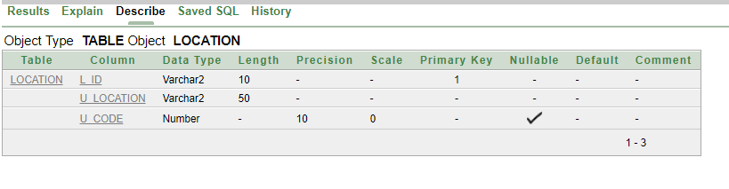

**2**. create table University(u_code number(10) primary key,u_name varchar2(50)not null, a_id varchar2(10));

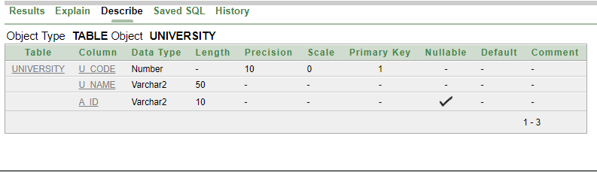

**3**. create table Administration(a_id varchar2(10) primary key,a_name varchar2(20)not null,a_phone number(11)unique,a_email varchar2(15)unique,a_designation varchar2(15));

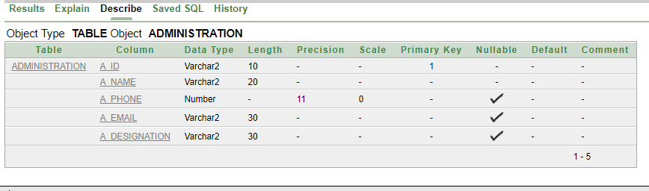

**4**. create table Department(d_id varchar2(10) primary key,d_name varchar2(50)not null,check(d_name IN('FACULTY OF SCIENCE & INFORMATION TECHNOLOGY','FACULTY OF ENGINEERING','FACULTY OF BUSINESS ADMINISTRATION','FACULTY OF ART & SOCIAL SCIENCES')),d_sector varchar2(6)not null,check (d_sector in('CSE','EEE','BBA','ENG','ACH','CSSE','SE','CS')),a_id varchar2(10));

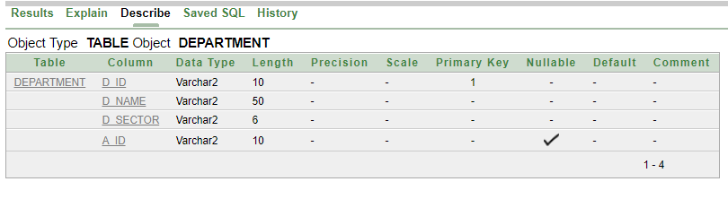

**5**. create table Teacher(t_id varchar2(10) primary key,t_name varchar2(20)not null,t_phone number(11)unique,t_email varchar2(15)unique,t_address varchar2(50)not null,join_date date not null,d_id varchar2(10),tpe_no number(4),research_id varchar2(10));

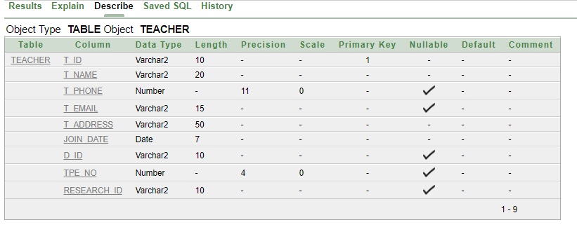

**6**. create table Teacher_Exchange(t_exchange_id varchar2(10) primary key,t_exchange_home varchar2(100)default NULL,t_exchange_abroad varchar2(100) default NULL,t_id varchar2(10),d_id varchar2(10));

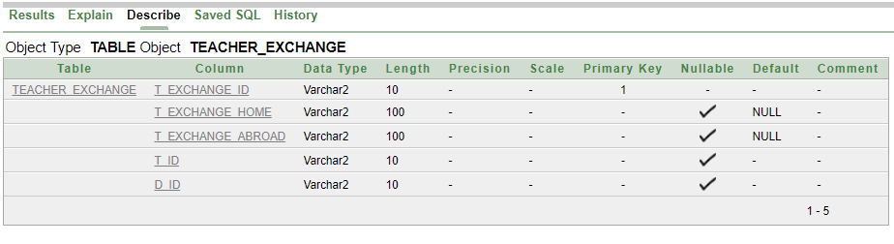

**7**. create table Course(c_credit number(2)not null,c_code number(4)not null,c_name varchar2(50)not null,t_id varchar2(10),d_id varchar2(10));

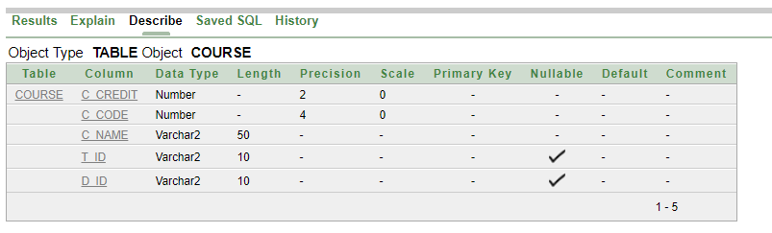

**8**. create table Salary(s_amount number(10)not null,s_no number(4) primary key,s_policy varchar2(10)default 'N\A',check(s_policy IN('Cash','Cheque')),t_id varchar2(10),u_code number(10));

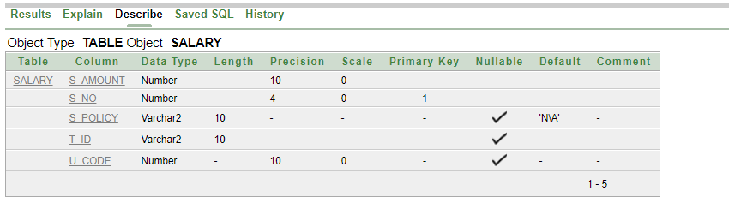

**9**. create table TPE(tpe_no number(4) primary key,tpe_comment varchar2(200)default 'NO COMMENTS',tpe_performance varchar2(10)not null,promotion_no number(4));

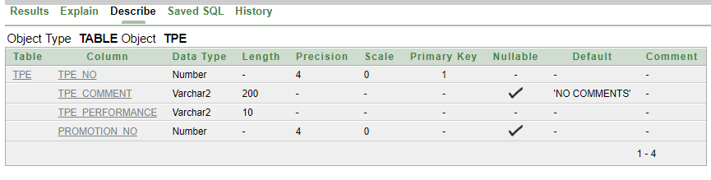

**10**. create table Attendance(a_date TIMESTAMP,a_ontime varchar2(5)not null,a_offtime varchar2(5)not null,t_id varchar2(10),r_id varchar2(10));

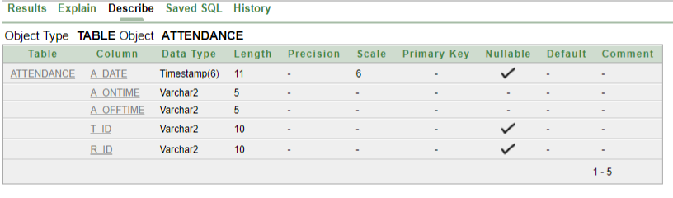

**11**. create table Registrar(r_id varchar2(10) primary key,r_name varchar2(15)not null,r_phone number(11)unique,r_email varchar2(50)unique);

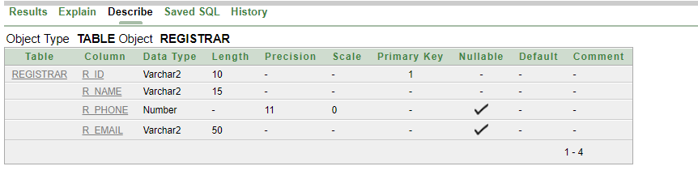

**12**. create table Promotion(promotion_no number(4) primary key,promotion_designation varchar2(20)not null,t_id varchar2(10));

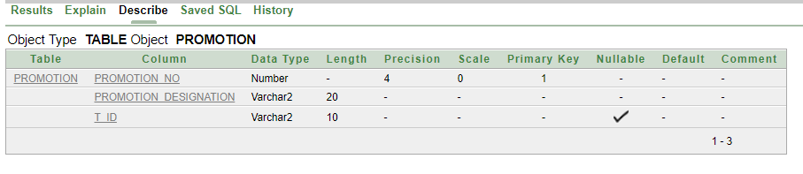

**13**. create table Vacation(v_date date primary key,v_day number(2) default 0,v_semester varchar2(15)default 'N\A',v_application varchar2(500)default 'N\A',r_id varchar2(10));

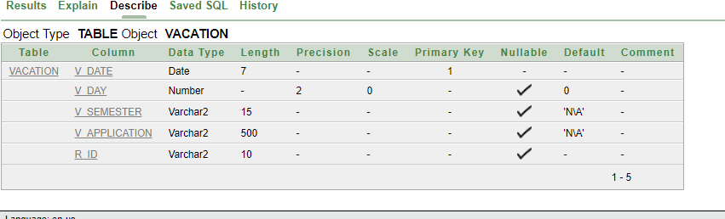

**14**. create table Vacation2(v_count number(2)default 0,v_date date,t_id varchar2(10));

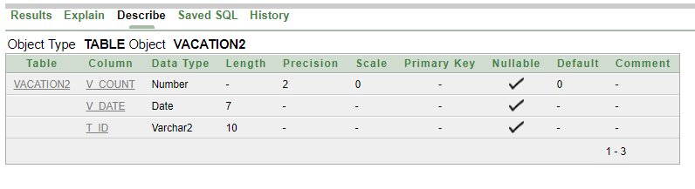

**15**. create table Foreign_Faculty(ff_id varchar2(10)primary key,ff_name varchar2(20)not null,ff_institution varchar2(100)not null,ff_designation varchar2(15) default 'N\A',ff_soial varchar2(500) default 'N\A',t_id varchar2(10));

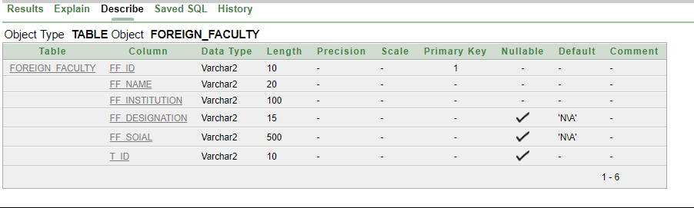

**16**. create table FF_Course(c_code number(4),ff_country varchar2(10)not null,ff_id varchar2(10));

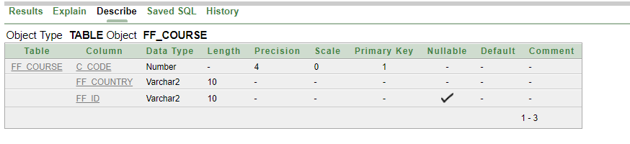

**17**. create table Research(research_id varchar2(10) primary key,research_name varchar2(50)not null,research_field varchar2(50)not null);

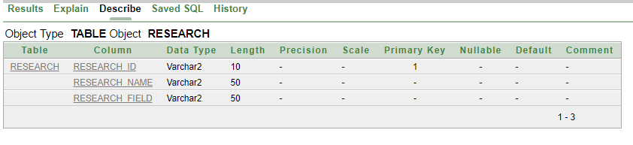

**18**. create table Grade(g_no number(4) primary key,g_system varchar2(10)not null, t_id varchar2(10));

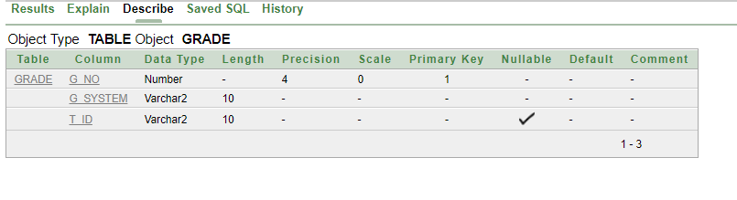

**19.** create table Consultant_Hour(room_no number(5)not null, class_hour varchar2(10), t_id varchar2(10));

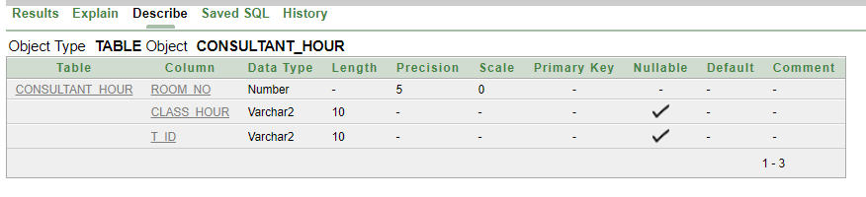

**CONSTRAINTS:**

**1.** alter table Location add constraint L1 foreign key(u_code) references University(u_code);

**2.** alter table University add constraint U1 foreign key(a_id) references Administration(a_id);

**3**. alter table Department add constraint D1 foreign key(a_id) references Administration(a_id);

**4**. alter table Teacher add constraint T1 foreign key(d_id) references Department(d_id);

**5**. alter table Teacher add constraint T2 foreign key(research_id) references Research(research_id);

**6**. alter table Teacher add constraint T3 foreign key(tpe_no) references TPE(tpe_no);

**7**. alter table Teacher_Exchange add constraint TE1 foreign key(t_id) references Teacher(t_id);

**8**. alter table Teacher_Exchange add constraint TE2 foreign key(d_id) references Department(d_id);

**9**. alter table Course add constraint C1 foreign key(d_id) references Department(d_id);

**10**. alter table Course add constraint C2 foreign key(t_id) references Teacher(t_id);

**11**. alter table Salary add constraint S1 foreign key(t_id) references Teacher(t_id);

**12**. alter table Salary add constraint S2 foreign key(u_code) references University(u_code);

**13**. alter table Attendance add constraint A1 foreign key(t_id) references Teacher(t_id);

**14**. alter table Attendance add constraint A2 foreign key(r_id) references Registrar(r_id);

**15**. alter table Vacation add constraint V1 foreign key(r_id) references Registrar(r_id);

**16**. alter table Vacation2 add constraint V21 foreign key(v_date) references Vacation(v_date);

**17**. alter table Vacation2 add constraint V22 foreign key(t_id) references Teacher(t_id);

**18**. alter table Foreign_Faculty add constraint FF1 foreign key(t_id) references Teacher(t_id);

**19**. alter table FF_Course add constraint FFC1 foreign key(ff_id) references Foreign_Faculty(ff_id);

**20**. alter table Grade add constraint G1 foreign key(t_id) references Teacher(t_id);

**21**. alter table Consultant_Hour add constraint CT1 foreign key(t_id) references Teacher(t_id);

**DATA INSERTION:**

1. Location:

insert into Location(l_id,u_location,u_code) values('78431','Kuratoli Road,Kuril,Khilkhet,Dhaka,Bangladesh','1229');

insert into Location(l_id,u_location,u_code) values('77450','Road No-10,Block-B,Banani,Dhaka,Bangladesh','1212');

insert into Location(l_id,u_location,u_code) values('78435','Road No-4,Block-A,Bashundhara,Dhaka,Bangladesh','1208');

insert into Location(l_id,u_location,u_code) values('78455','Aftabnagar,Rampura,Dhaka,Bangladesh','1215');

insert into Location(l_id,u_location,u_code) values('78433','Mohakhali,66 Bir Uttam Road,Dhaka,Bangladesh','1205');

2. University:

insert into University (u_code,u_name,a_id) values('1229','American International University Bangladesh','13-77334-1');

insert into University (u_code,u_name,a_id) values('1212','South East University','Road No-10,Block-B,Banani,Dhaka,Bangladesh','12-55434-1');

insert into University (u_code,u_name,a_id) values('1208','North South University','Road No-4,Block-A,Bashundhara,Dhaka,Bangladesh','14-31471-2');

insert into University (u_code,u_name,a_id) values('1215','East West University','Aftabnagar,Rampura,Dhaka,Bangladesh','11-55431-3');

insert into University (u_code,u_name,a_id) values('1205','Brac University','Mohakhali,66 Bir Uttam AK Khandakar Road,Dhaka,Bangladesh','10-13545-1');

3. Administration:

insert into Administration(a_id,a_name,a_phone,a_email,a_designation) values ('13-77334-1','Md Marufuzzaman','01815414282','marufuzzaman@aiub.edu','Administrative Assistant');

insert into Administration(a_id,a_name,a_phone,a_email,a_designation) values ('14-31471-2','Mukit Islam','01741404605','mukit@nsu.edu','Administrative Director');

insert into Administration(a_id,a_name,a_phone,a_email,a_designation) values ('12-55434-1','Md Asif Rahman','01711532652','asifrahman@seu.edu','Administrative Coordinator');

insert into Administration(a_id,a_name,a_phone,a_email,a_designation) values ('11-55431-3','Khorshed Alam','01613414282','khorshed@ewu.edu','Administrative Manager');

insert into Administration(a_id,a_name,a_phone,a_email,a_designation) values ('10-13545-1','Khairul Bhuiyan','01971749730','khairul@brac.edu','Administrator');

4. Department:

insert into Department(d_id,d_name,d_sector,a_id) values('FSIT-105','FACULTY OF SCIENCE & INFORMATION TECHNOLOGY','CSE','13-77334-1');

insert into Department(d_id,d_name,d_sector,a_id) values('FSIT-107','FACULTY OF SCIENCE & INFORMATION TECHNOLOGY','CSSE','14-31471-2');

insert into Department(d_id,d_name,d_sector,a_id) values('ENGG-113','FACULTY OF ENGINEERING','EEE','12-55434-1');

insert into Department(d_id,d_name,d_sector,a_id) values('ENGG-115','FACULTY OF ENGINEERING','ACH','11-55431-3');

insert into Department(d_id,d_name,d_sector,a_id) values('FBA-109','FACULTY OF BUSINESS ADMINISTRATION','BBA','10-13545-1');

5. Teacher:

insert into Teacher(t_id,t_name,t_phone,t_email,t_address,join_date,d_id,tpe_no,research_id) values ('11-33451-1','Rumana Afrin','01711721452','rafrin@aiub.edu','911/4,Rajarbag,Dhaka,Bangladesh','11-FEB-13','FSIT-105','211','7809');

insert into Teacher(t_id,t_name,t_phone,t_email,t_address,join_date,d_id,tpe_no,research_id) values ('02-33435-1','Juena Nowshin','01785412580','juena@aiub.edu','Road NO-8,Sector-6,Uttara,Dhaka,Bangladesh','02-MAY-31','FSIT-107','231','7812');

insert into Teacher(t_id,t_name,t_phone,t_email,t_address,join_date,d_id,tpe_no,research_id) values ('07-55132-2','Salma Nur','01535471489','salma@aiub.edu','Road N0-3,House No-3/B,Banasree,Dhaka,Bangladesh','07-MAR-10','ENGG-113','233','7810');

insert into Teacher(t_id,t_name,t_phone,t_email,t_address,join_date,d_id,tpe_no,research_id) values ('13-35250-3','Sumaiya Islam','01711285723','sislam@aiub.edu','Road No-1,Jorpukur Par,Khilgaon,Dhaka,Bangladesh','13-OCT-17','ENGG-115','215','7815');

insert into Teacher(t_id,t_name,t_phone,t_email,t_address,join_date,d_id,tpe_no,research_id) values ('15-33225-1','Muniba Bari','01686974686','mbari@aiub.edu','Road No-7,House No-313,Banani,Dhaka,Bangladesh','15-DEC-23','FBA-109','218','7820');

6. Teacher_Exchange:

insert into Teacher_Exchange(t_exchange_id,t_exchange_home,t_exchange_abroad,t_id,d_id) values ('13','United International Universitty','','11-33451-1','FSIT-105')

insert into Teacher_Exchange(t_exchange_id,t_exchange_home,t_exchange_abroad,t_id,d_id) values ('23','','Melbourne University','02-33435-1','FSIT-107');

insert into Teacher_Exchange(t_exchange_id,t_exchange_home,t_exchange_abroad,t_id,d_id) values ('27','North South University','','07-55132-2','ENGG-113');

insert into Teacher_Exchange(t_exchange_id,t_exchange_home,t_exchange_abroad,t_id,d_id) values ('33','Brac Universitty','','13-35250-3','ENGG-115');

insert into Teacher_Exchange(t_exchange_id,t_exchange_home,t_exchange_abroad,t_id,d_id) values ('39','','Hokkaido University','15-33225-1','FBA-109');

7. Course:

insert into Course(c_credit,c_code,c_name,d_id,t_id) values ('3','2211','Intoduction To Database','FSIT-105','11-33451-1');

insert into Course(c_credit,c_code,c_name,d_id,t_id) values ('3','2213','Algorithm','FSIT-107','02-33435-1');

insert into Course(c_credit,c_code,c_name,d_id,t_id) values ('3','1115','Physics-1','ENGG-113','07-55132-2');

insert into Course(c_credit,c_code,c_name,d_id,t_id) values ('3','1117','Electrical Circuits-1','ENGG-115','13-35250-3');

insert into Course(c_credit,c_code,c_name,d_id,t_id) values ('3','3122','Principle Of Accounting','FBA-109','15-33225-1');

8. Salary:

insert into Salary(s_amount,s_no,s_policy,t_id,u_code) values ('60000','103','Cash','11-33451-1','1229');

insert into Salary(s_amount,s_no,s_policy,t_id,u_code) values ('100000','104','Cheque','02-33435-1','1212');

insert into Salary(s_amount,s_no,s_policy,t_id,u_code) values ('50000','105','Cash','07-55132-2','1208');

insert into Salary(s_amount,s_no,s_policy,t_id,u_code) values ('80000','109','Cheque','13-35250-3','1215');

insert into Salary(s_amount,s_no,s_policy,t_id,u_code) values ('150000','107','','15-33225-1','1205');

9. TPE:

insert into TPE(tpe_no,tpe_comment,tpe_performance,promotion_no) values ('211','Praises,elicits and responds to student questions','Good','103');

insert into TPE(tpe_no,tpe_comment,tpe_performance,promotion_no) values ('231','Teaches accurate and up-to-date information','Best','105');

insert into TPE(tpe_no,tpe_comment,tpe_performance,promotion_no) values ('233','Coordinates learning content with instructional objectives','Average','109');

insert into TPE(tpe_no,tpe_comment,tpe_performance,promotion_no) values ('215','Presents learning content in a logical sequential order','Good','107');

insert into TPE(tpe_no,tpe_comment,tpe_performance,promotion_no) values ('218','Encourages participation from all students','Worst','111');

10. Attendance:

insert into Attendance(a_date,a_ontime,a_offtime,t_id,r_id) values ('13-MAY-05 07:15:31','Yes','No','11-33451-1','15-22471-1');

insert into Attendance(a_date,a_ontime,a_offtime,t_id,r_id) values ('14-JAN-07 07:58:26','No','Yes','15-33225-1','14-33225-1');

insert into Attendance(a_date,a_ontime,a_offtime,t_id,r_id) values ('25-MAY-05 07:48:11','Yes','No','02-33435-1','10-22391-3');

insert into Attendance(a_date,a_ontime,a_offtime,t_id,r_id) values ('27-MAR-05 07:30:51','Yes','No','07-55132-2','12-44557-1');

insert into Attendance(a_date,a_ontime,a_offtime,t_id,r_id) values ('19-NOV-05 08:03:13','Yes','No','13-35250-3','05-22471-3');

11. Registrar:

insert into Registrar(r_id,r_name,r_phone,r_email) values ('15-22471-1','Mijan Alam','01625812345','mijan@gmail.com');

insert into Registrar(r_id,r_name,r_phone,r_email) values ('14-33225-1','Tanvir Alam','01512398758','talam@gmail.com');

insert into Registrar(r_id,r_name,r_phone,r_email) values ('10-22391-3','Polash Bhuiyan','01974749730','polash@yahoo.com');

insert into Registrar(r_id,r_name,r_phone,r_email) values ('12-44557-1','Shibli Mahmud','01815414282','shibli@outlook.com');

insert into Registrar(r_id,r_name,r_phone,r_email) values ('05-22471-3','Nasir Uddin','01532652159','nasir@gmail.com');

12. Promotion:

insert into Promotion(promotion_no,promotion_designation,t_id) values ('103','Associate Professor','11-33451-1');

insert into Promotion(promotion_no,promotion_designation,t_id) values ('105','Dean','02-33435-1');

insert into Promotion(promotion_no,promotion_designation,t_id) values ('109','Assistant Professor ','07-55132-2');

insert into Promotion(promotion_no,promotion_designation,t_id) values ('107','Senior Lecturer ','13-35250-3');

insert into Promotion(promotion_no,promotion_designation,t_id) values ('111','Lecturer','15-33225-1');

13. Vacation:

insert into Vacation(v_date,v_day,v_semester,v_application,r_id) values ('11-FEB-13','10','Spring,17-18','With Application','15-22471-1');

insert into Vacation(v_date,v_day,v_semester,v_application,r_id) values ('02-MAY-31','5','Summer,12-13','Without Application','14-33225-1');

insert into Vacation(v_date,v_day,v_semester,v_application,r_id) values ('07-MAR-10','1','Spring,17-18','With Application','10-22391-3');

insert into Vacation(v_date,v_day,v_semester,v_application,r_id) values ('13-OCT-17','2','Summer,15-16','Without Application','12-44557-1');

insert into Vacation(v_date,v_day,v_semester,v_application,r_id) values ('17-AUG-22','6','Fall,17-18','Without Application','05-22471-3');

14. Vacation2:

insert into Vacation2(v_count,v_date,t_id) values ('1','17-AUG-22','11-33451-1');

insert into Vacation2(v_count,v_date,t_id) values ('2','13-OCT-17','02-33435-1');

insert into Vacation2(v_count,v_date,t_id) values ('1','07-MAR-10','07-55132-2');

insert into Vacation2(v_count,v_date,t_id) values ('1','02-MAY-31','13-35250-3');

insert into Vacation2(v_count,v_date,t_id) values ('1','11-FEB-13','15-33225-1');

15. Foreign_Faculty:

insert into Foreign_Faculty(ff_id,ff_name,ff_institution,ff_designation,ff_soial,t_id) values ('03-47584-1','Prof.Kashinath Roy','University of Delhi','Dean','','11-33451-1');

insert into Foreign_Faculty(ff_id,ff_name,ff_institution,ff_designation,ff_soial,t_id) values ('07-47584-3','Jacob Jones','University of Auckland','Professor','','02-33435-1');

insert into Foreign_Faculty(ff_id,ff_name,ff_institution,ff_designation,ff_soial,t_id) values ('12-45784-2','kane Willamson','Monash University','Senior Lecturer','','07-55132-2');

insert into Foreign_Faculty(ff_id,ff_name,ff_institution,ff_designation,ff_soial,t_id) values ('15-47584-3','Wriddiman Shaha','University of Mumbai','Lecturer','','13-35250-3');

insert into Foreign_Faculty(ff_id,ff_name,ff_institution,ff_designation,ff_soial,t_id) values ('13-47584-2','Dr.Steven Scott','University of Adelaide','Professor','','15-33225-1');

16. FF_Course:

insert into FF_Course(c_code,ff_country,ff_id) values ('2311','India','03-47584-1');

insert into FF_Course(c_code,ff_country,ff_id) values ('1122','NewZealand','07-47584-3');

insert into FF_Course(c_code,ff_country,ff_id) values ('3112','Australia','12-45784-2');

insert into FF_Course(c_code,ff_country,ff_id) values ('2142','India','15-47584-3');

insert into FF_Course(c_code,ff_country,ff_id) values ('2411','Australia','13-47584-2');

17. Research:

insert into Research(research_id,research_name,research_field) values ('7809','Developing Computer Security','Algorithmics,Programming,Software');

insert into Research(research_id,research_name,research_field) values ('7812','Measuring X-Ray Wave Using Laplace','Applied Mathematics, Computation and Simulation');

insert into Research(research_id,research_name,research_field) values ('7810','The Internet Of Things','Networks,Systems,Distributed Computing');

insert into Research(research_id,research_name,research_field) values ('7815','Parallel Architecture Computing','Architecture');

insert into Research(research_id,research_name,research_field) values ('7820','Fuel Cells,Solar Energy','Energy Engineering');

18. Grade:

insert into Grade(g_no,g_system,t_id) values ('145','Average','11-33451-1');

insert into Grade(g_no,g_system,t_id) values ('155','Break Down','02-33435-1');

insert into Grade(g_no,g_system,t_id) values ('115','Partial','07-55132-2');

insert into Grade(g_no,g_system,t_id) values ('135','Average','13-35250-3');

insert into Grade(g_no,g_system,t_id) values ('116','Average','15-33225-1');

19. Consultant:

insert into Consultant_Hour(room_no,class_hour,t_id) values ('43112','10-2','11-33451-1');

insert into Consultant_Hour(room_no,class_hour,t_id) values ('43114','8-12','02-33435-1');

insert into Consultant_Hour(room_no,class_hour,t_id) values ('43222','12-5','07-55132-2');

insert into Consultant_Hour(room_no,class_hour,t_id) values ('43102','11-3','13-35250-3');

insert into Consultant_Hour(room_no,class_hour,t_id) values ('43212','10-4','15-33225-1');

**QUERY WRITING:**

Single Row Functions:

Que: Display all data of teacher rumana afrin.

Ans: select * from Teacher where lower(t_name)='rumana afrin';

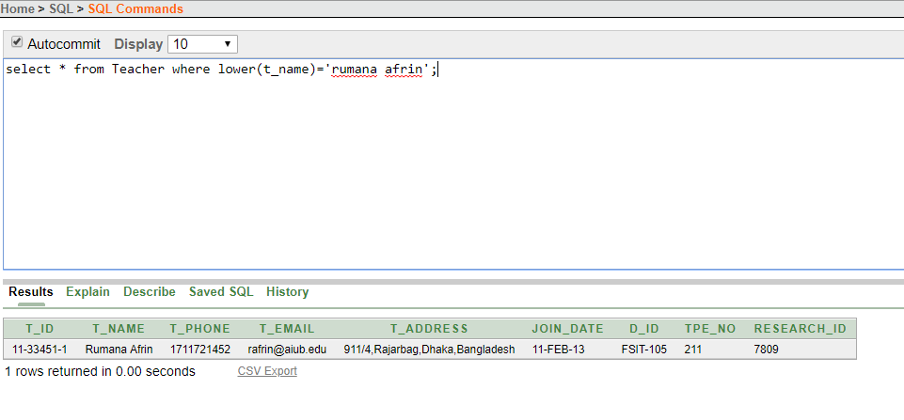

Ques: Display department name,length of department name,the first position of Alphabet F in department name of FSIT id holder.

Ans: select d_name,LENGTH(d_name),INSTR(d_name,'F') from Department where SUBSTR(d_id,1,4)='FSIT';

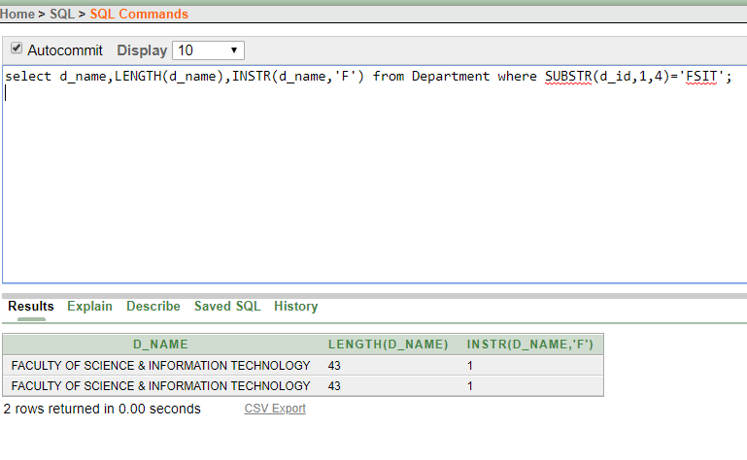

Ques: Display the joindate of all teachers in the format DD-MONTH-YYYY(e.g 17 December 1980).

Ans: select t_name,TO_CHAR(join_date, 'fmDD Month YYYY') JOINDATE from Teacher;

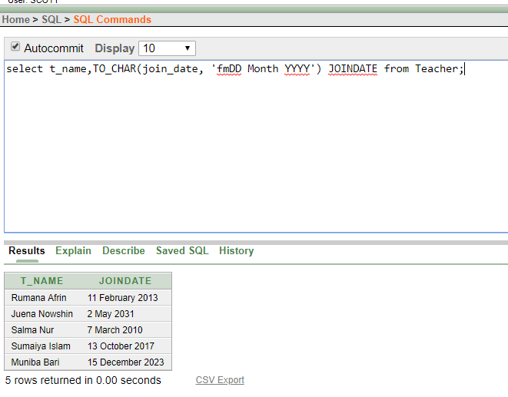

Group Functions:

Ques: Find the average, minimum and maximum salary of the teachers.Label the columns AVG, MIN and MAX respectively.

Ans: select AVG(s_amount) AVG,MIN(s_amount) MIN,MAX(s_amount) MAX from Salary;

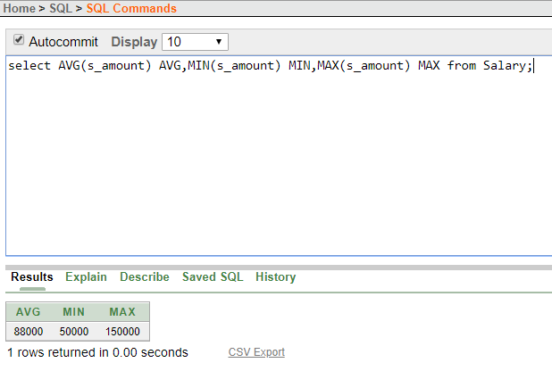

Ques: Display the sum of salaries grouped by the teahers id.

Ans: select t_id,SUM(s_amount) from Salary group by t_id;

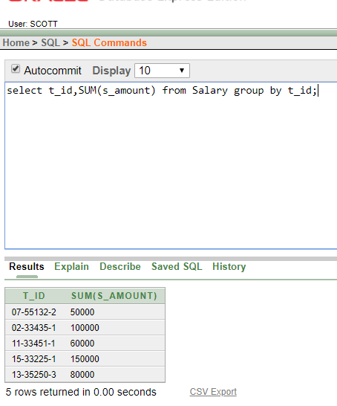

Ques: Display the sum of salaries grouped by the salary number and teachers id but the sum of salary must be greater than 65000.

Ans: select t_id,s_no,SUM(s_amount) from Salary group by t_id,s_no having SUM(s_amount)>'65000';

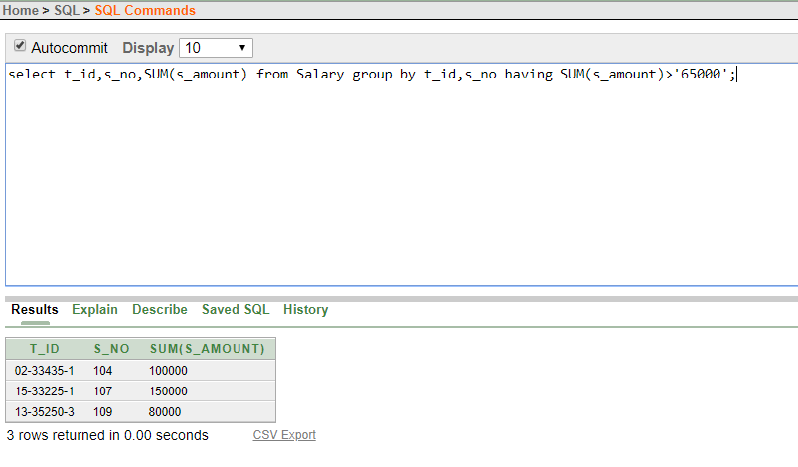

Subquery:

Ques: Display the teachers names who joined after Rumana Afrin.

Ans: select t_name from Teacher where join_date>(select join_date from Teacher where t_name='Rumana Afrin');

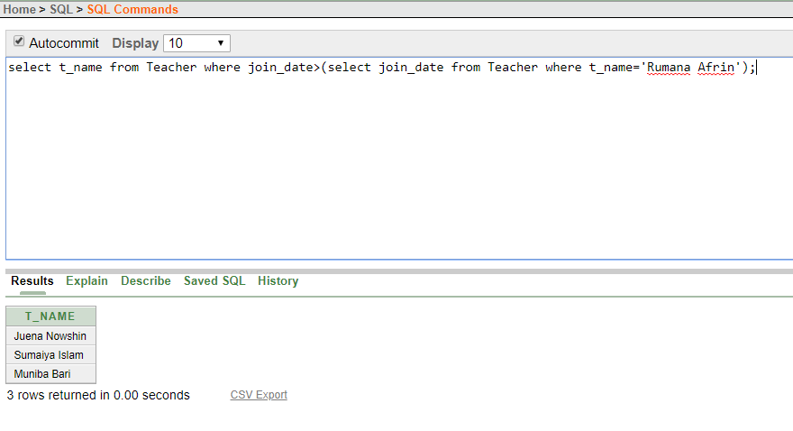

Ques: Display the id of the teacher who earn more than 07-55132-2 id.

Ans: select t_id from Salary where s_amount>(select s_amount from Salary where t_id='07-55132-2');

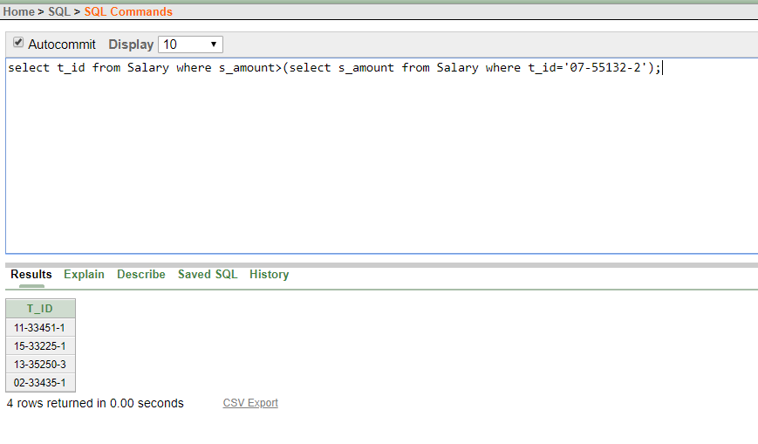

Joining:

Ques: Display the name of the teachers whose tpe performance is good.

Ans: select Teacher.t_name,TPE.tpe_performance from Teacher,TPE where tpe_performance='Good' AND Teacher.tpe_no=TPE.tpe_no;

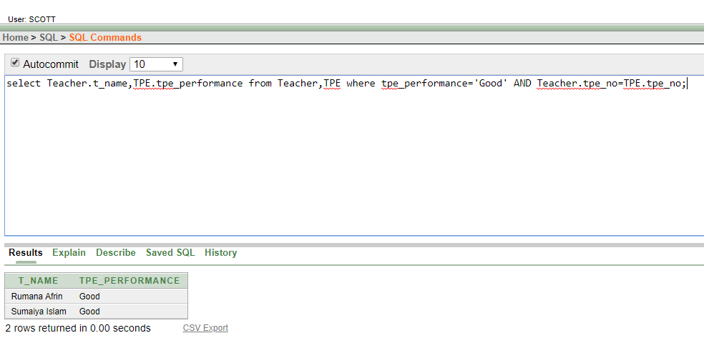

Ques: Display the name of foreign faculty who are from India.

Ans: select Foreign_Faculty.ff_name,FF_Course.ff_country from Foreign_Faculty,FF_Course where ff_country='India' AND Foreign_Faculty.ff_id=FF_Course.ff_id;

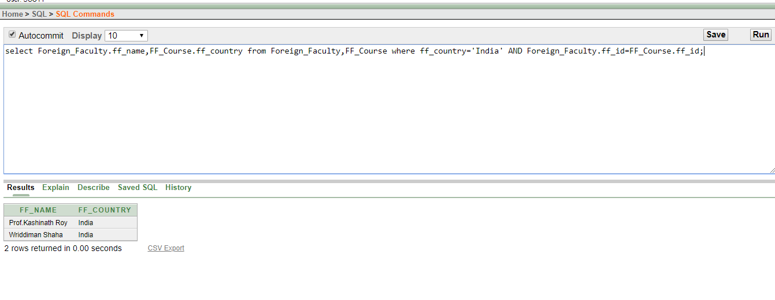

**CONCLUSION:** After finished this project we have learned many things like how we can make database, making scenario, normalization, query and lot of this. We all have enjoyed.

Thank You